Loop & Duplicate Traffic Avoidance

Overview
In the project of multicast forwarding, an aggregator is a Windows service that has tree major interfaces:
- Listener - will listen at UDP layer, and receive multicast packages on its local subnet.
- Tunnels – are fault resilient TCP connections to other aggregator instance, they pass the multicast messages received by Multicast Listener to the destination aggregator
- Resender – the destination aggregator re-multicast the message, received by the source listener and forwarded thru the tunnel, on its local LAN
The aggregator will forward the multicast messages on the source LAN to the target LAN. However, in some deployment, forwarding multicast message may cause loop traffic or duplicate traffic.

Network topologies
If there are no avoidances, loop traffic will happen in some deployment networks:

Loop traffic between two aggregators
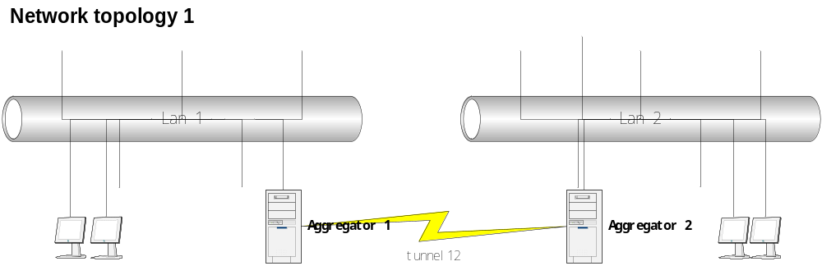
In Network topology 1, Aggregator 1 detects a multicast message and transfers it to aggregator 2 thru tunnel12. Aggregator 2 re-multicast the message on LAN 2, and receives the same message thru its own listener interface and transfer back to aggregator 1. Aggregator 1 repeat the same process as aggregator 2 just did, the message will be ping-ponged between the two aggregators.

Loop-ed tunnels
Loop traffic can also happen when multiple aggregators build up tunnel loops. Network topology 2 below shows a typical direct tunnel loop, which is built with tunnels only.
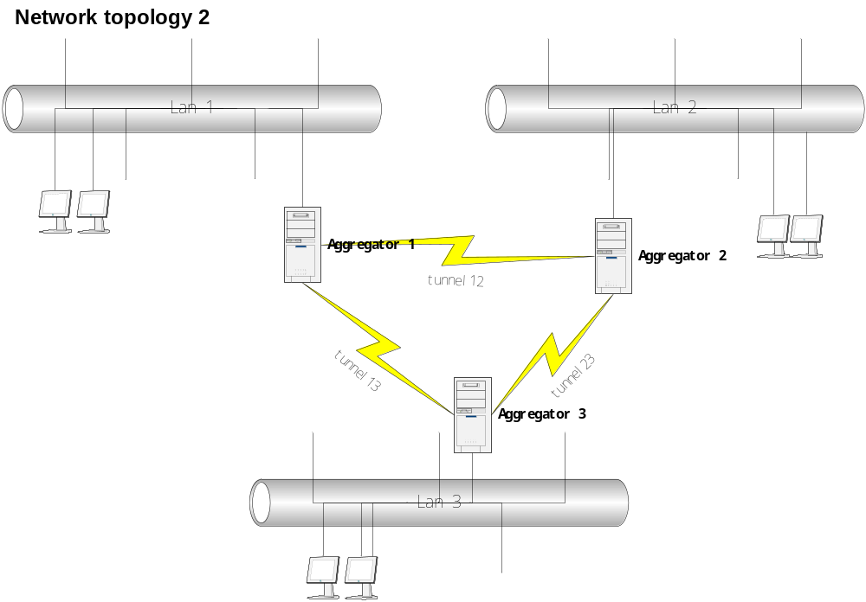
The tunnel loops can also be in-direct as shown in Network topology 3 and Network topology 4, when the loop includes not only the tunnels but also multicast LAN.
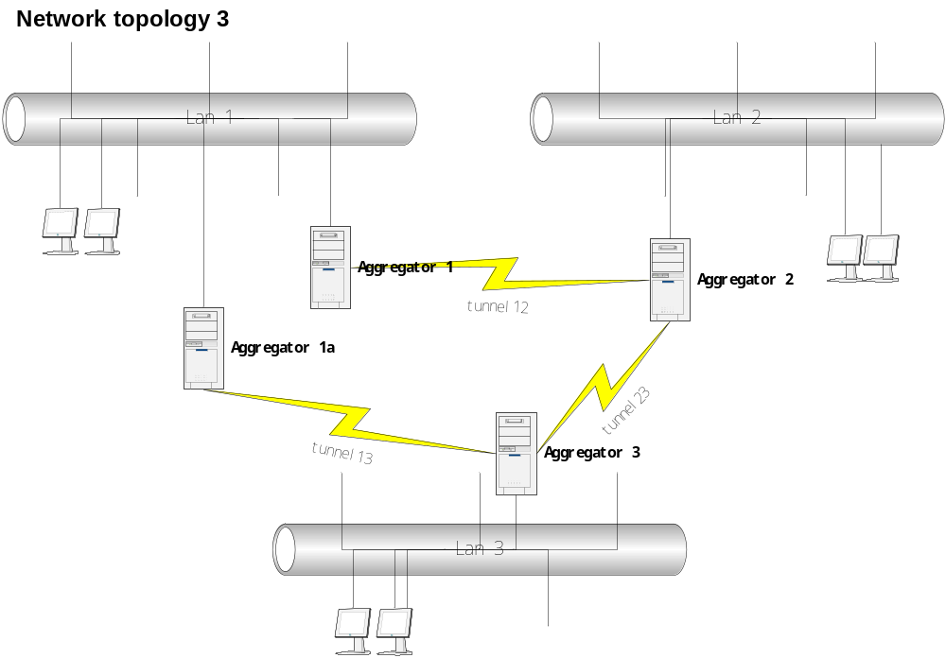

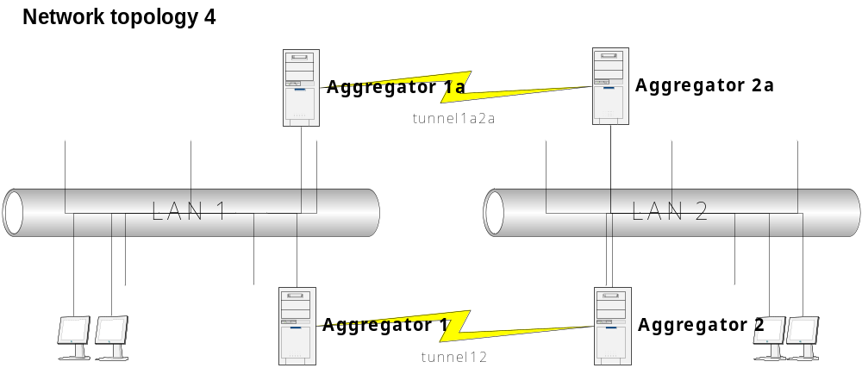

Loop Avoidance
There are many possible solutions to avoid the loop traffic. In the project of multicast forwarding, the following constraints must be considered:
- The aggregator must run without blocking any other multicast service/application on the same machine.
- The listener interface must listen at UDP layer

Base-on the above constraints, this section will describe an approach to avoid the loop traffic.

Rules applied to the resender interface
In order let the aggregator can separate the re-multicasted messages from others, some rules will be applied to the resender interface. When the resender interface is going to re-multicast a message forward thru the tunnel, it will:
- Send the message thru one specified IP/port of the machine it runs on. The IP and port are configurable
- Keep the destination IP/port of the outgoing package as same as that when it was received by the source aggregator
- Set the TTL of the outgoing package to 1 to prevent it from going through any routers

Rules applied to the listener interface
The listener interface must separate those re-multicasted messages from others. The aggregator should not forward such messages to any other aggregators thru tunnels. The identification is used here will be base-on the specified port number mentioned in 3.1-1, or a denied-list which is configurable.

Duplicate Package and Avoidance
In an indirect tunnel loop network typically as shown in topology 4. When a machine on LAN1 multicasts a message, aggregator 1 receives and forwards it to aggregator 2, aggregator 2 re-multicast it on LAN2, say mc-package 12; meanwhile, the aggregator 1a receives the same package on LAN1 so that the aggregator 2a re-multicast it on LAN2 too, say mc-package 1a2a. The re-multicasted packages 12 and 1a2a are same except the routine info. So, any machine on LAN2 will receive the same content twice whenever a machine on LAN1 multicasts a message.

Avoidance Approach
The approach described here is based-on the constraint that the direct loop traffic has been avoided. In network topology 4, assume the tunnel 1a-2a exists and each aggregator has a unique identification (ID, maybe a chunk of random data generated when it is installed).

Service starting
When aggregator starts, it processes the following steps:
- Aggregator 1 makes a tunnel connection to aggregator 2, exchanges IDs to each other
- Aggregator 2 multicast a UDP ping package on LAN2 by filling in the information
Ordinal-code | ID1 | ID2 | \00 | \00
- Aggregator 2a receives the multicast package, and forwards the package to aggregator 2 with filling its own ID:
Ordinal-code | ID1 | ID2 | ID2a | \00
- Aggregator 1a re-multicast the package with filling its own too:
Ordinal-code | ID1 | ID2 | ID2a | ID1a
- Aggregator 1 received the package so that it know there is a tunnel already exists, it shuts down the tunnel to 2 and keep a record the map its own tunnel ID1-ID2 to ID2a-ID1a
- If Aggregator 1 can not receive such a loop-back message in a timeout period, it becomes full functional, and also broadcasts heart beat messages (with the active ID1-ID2 info) in regular intervals on LAN1

Down Tunnel Detection
Here are two ways to detect if an existing tunnel is down:
- If the aggregator service is on but the tunnel connection is down and even can not be recovered by invoking MtTcpComm, the aggregator can broadcast its failure on LAN
- If the pending aggregators (see 4.1.1-5) haven’t received the heart beat message for a timeout period, it can think that active tunnel is down

Challenge for Active Tunnel
If there are multiple pending aggregators exist, a challenge is necessary. Once an aggregator detects an active tunnel, who suspended its own tunnel, is down.
- It broadcasts a bid message with a large-range random number.
- Also, it listens for a period (maybe 2 times of the heart beat timeout) to collect the bids from others
- Give up if received bigger bid from others, but maintain the map as it is done in 4.1.1-5
- If it is the top bid when timeout, go to the step 4.1.1-6

